

**Data Mining And Warehousing**

**PEC**

**INTERNAL EVALUATION-1**

**Name**-Prathamesh Bachhav

**Roll no**-TYCOA014

**Division**-A

|  | **CONTENTS:**   1. **Title** 2. **Dataset used** 3. **Dataset Details** 4. **Preprocessing Methods Used** 5. **Tools/ Applications/ Language Used** 6. **Tools/ Applications/ Language Description** 7. **Preprocessing Methods in Description** 8. **Implementation Details** 9. **Conclusion** |
| --- | --- |
|  | |  | | --- | |

**A] TITLE-**

**B] Dataset Used-**

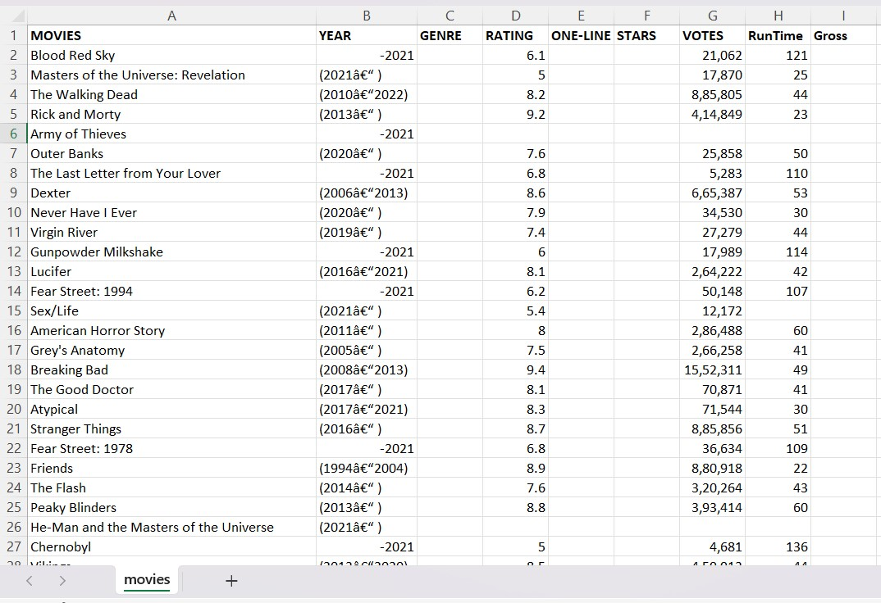

**C]Dataset Details-**

**D]Preprocessing Used-**

1. **Selecting required columns**
2. **Eliminating NULL values**
3. **Eliminating duplicate values**
4. **Handling the outliers**

**E]Tools / Application / Language Used -**

The preprocessing is done with the help of Python Programming language. Web-Based interactive environment used- Jupyter Notebook. Programming tools used are Numpy and Pandas. Pandas is used for representation of complete dataset whereas Numpy is used for all the preprocessing steps.

**F] Tools / Application / Language Details –**

**1.** **Python as a Programming Language:** Python is a high-level, interpreted programming language known for its simplicity and readability. It is versatile and widely used in various domains, including web development, data analysis, machine learning, scientific computing, and more. Python's easy-to-read syntax and extensive standard library make it a popular choice for both beginners and experienced developers.

**2.** **Pandas:** Pandas is an open-source Python library that provides high performance data structures and data analysis tools. It is particularly valuable for data manipulation, cleaning, and analysis. Pandas introduces two main data structures, the DataFrame and Series, which allow users to work with tabular data effectively. It's an essential tool for anyone dealing with data in Python.

**3.** **NumPy:** NumPy, short for Numerical Python, is a fundamental library for numerical and scientific computing in Python. It provides support for multi-dimensional arrays and matrices, along with a wide range of mathematical functions to operate on these arrays. NumPy is the foundation for many other scientific and data manipulation libraries in Python, and it's crucial for tasks like linear algebra, statistics, and more.

**4.Jupyter:** Jupyter is an open-source application that allows interactive and collaborative computing. Jupyter Notebook and JupyterLab are popular interfaces that enable users to create and share documents that contain live code, equations, visualisations, and narrative text. Jupyter is widely used in data analysis, research, and education. It supports multiple programming languages, with Python being one of the most commonly used languages in Jupyter environments.

# **G] Preprocessing Methods in Description-**

1. **Eliminating NA Values:** Eliminating NA (Not Available) or missing values is crucial for data preprocessing. It involves identifying and removing rows or columns that contain missing data, ensuring the dataset is complete and suitable for analysis.

2. **Eliminating Duplicates:** Eliminating duplicates involves identifying and removing duplicate rows from a dataset. Duplicate data can skew analysis and modelling results, so it's essential to handle them appropriately.

3. **Handling Outliers**: Eliminating the outliers is a data processing step that involves identifying and excluding data points that are significantly different from the majority of the data. Outliers can distort statistical analyses and machine learning models, so addressing them is crucial.

# 

# **H] Implementation Details-**

**Extract the data**

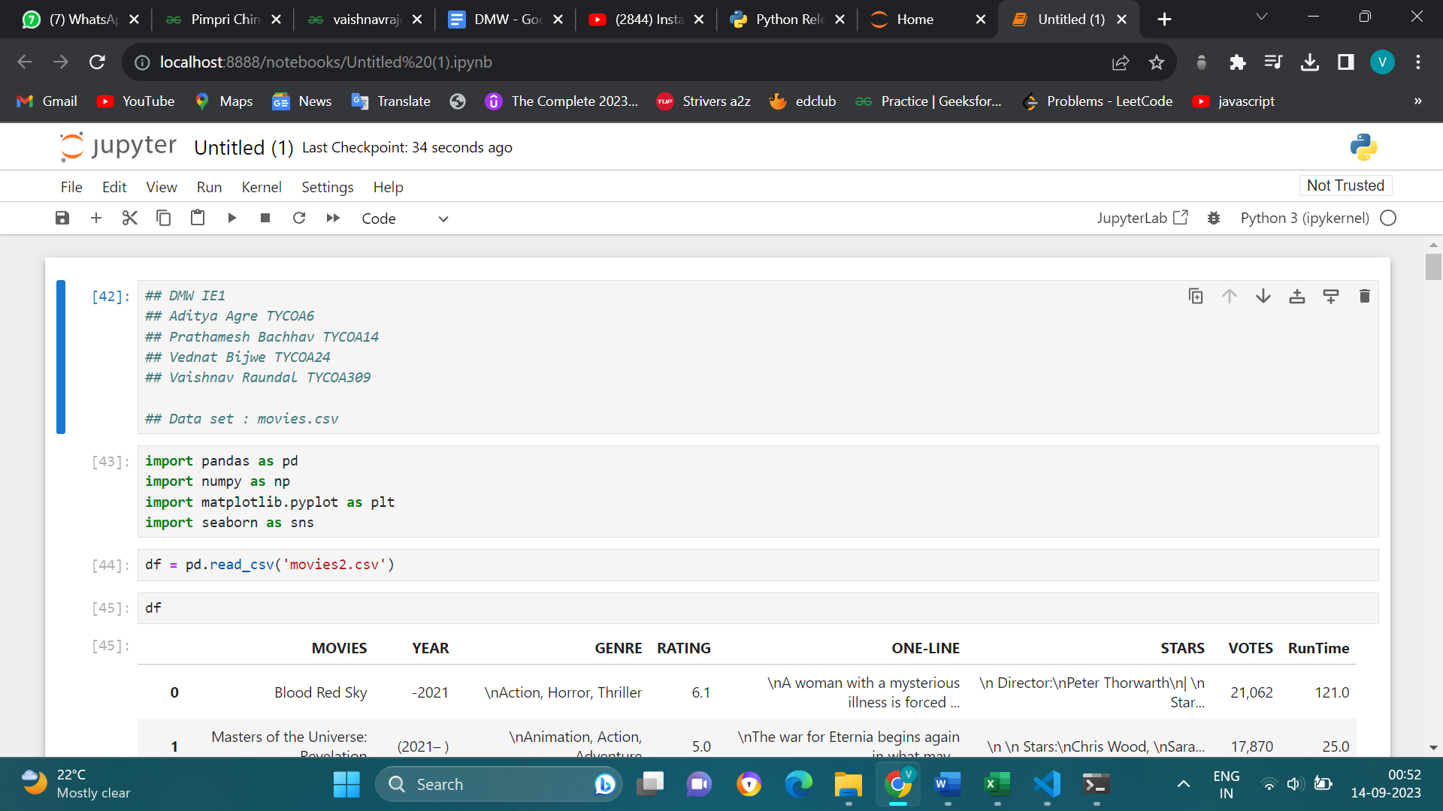

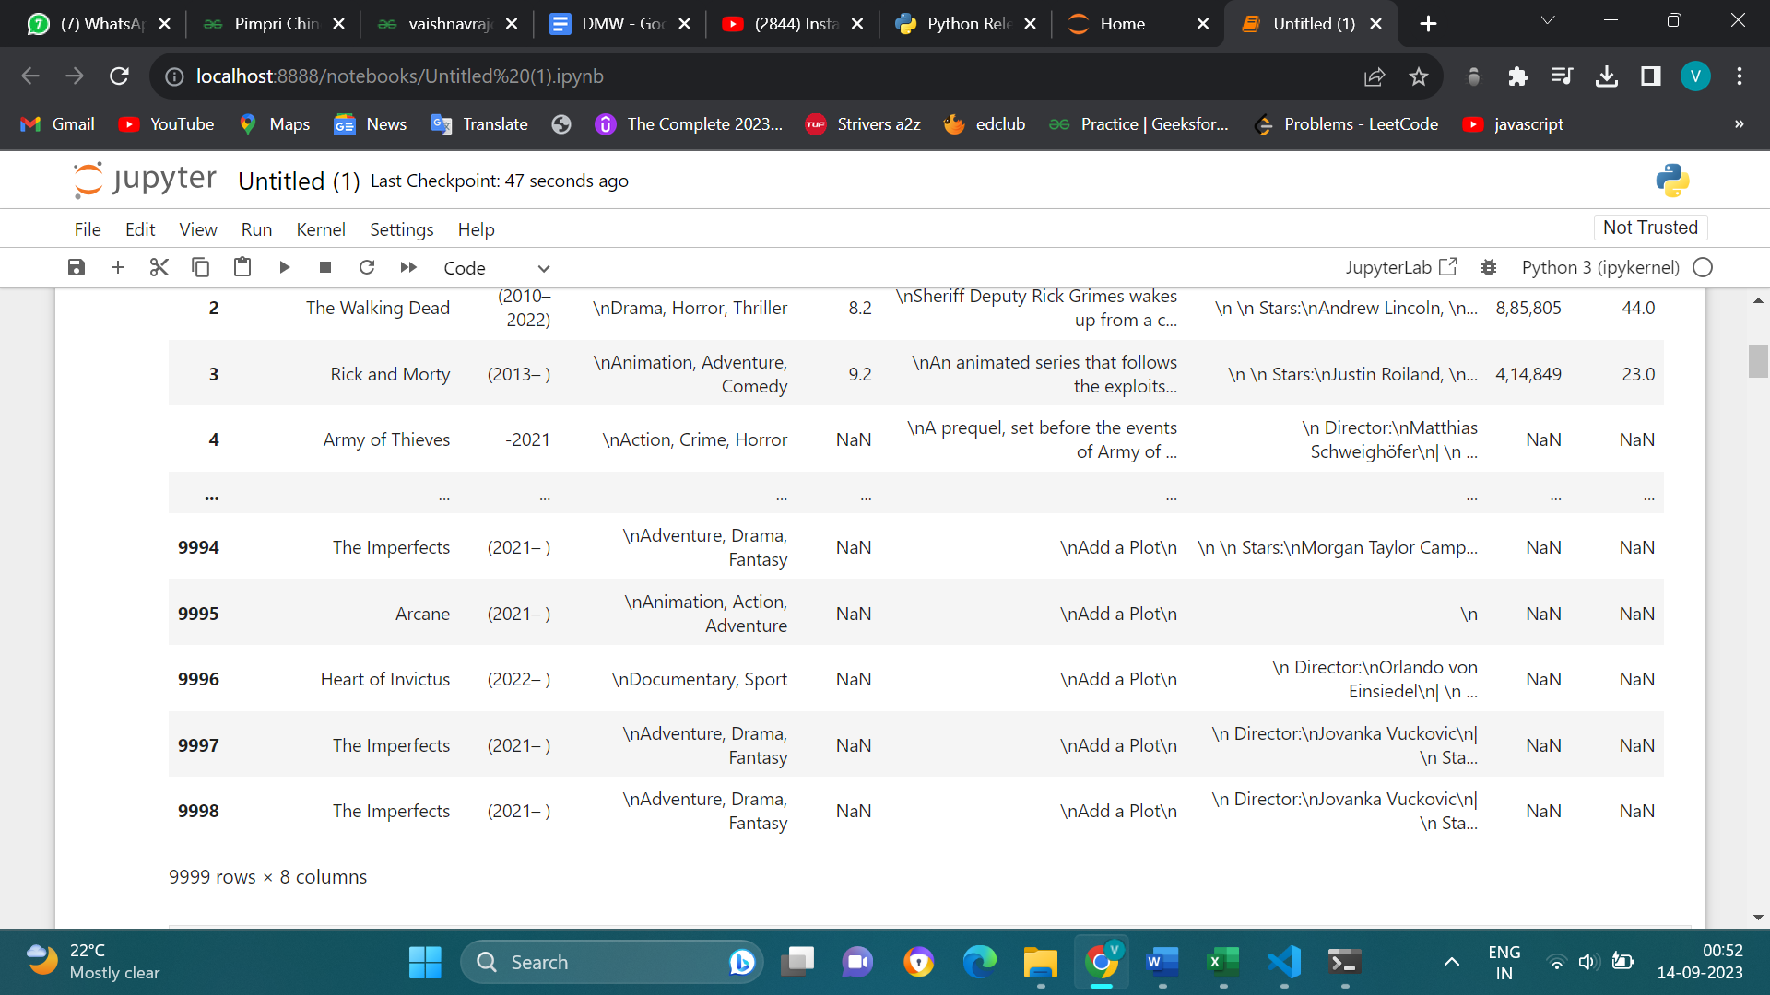

**Dealing with NULL values**

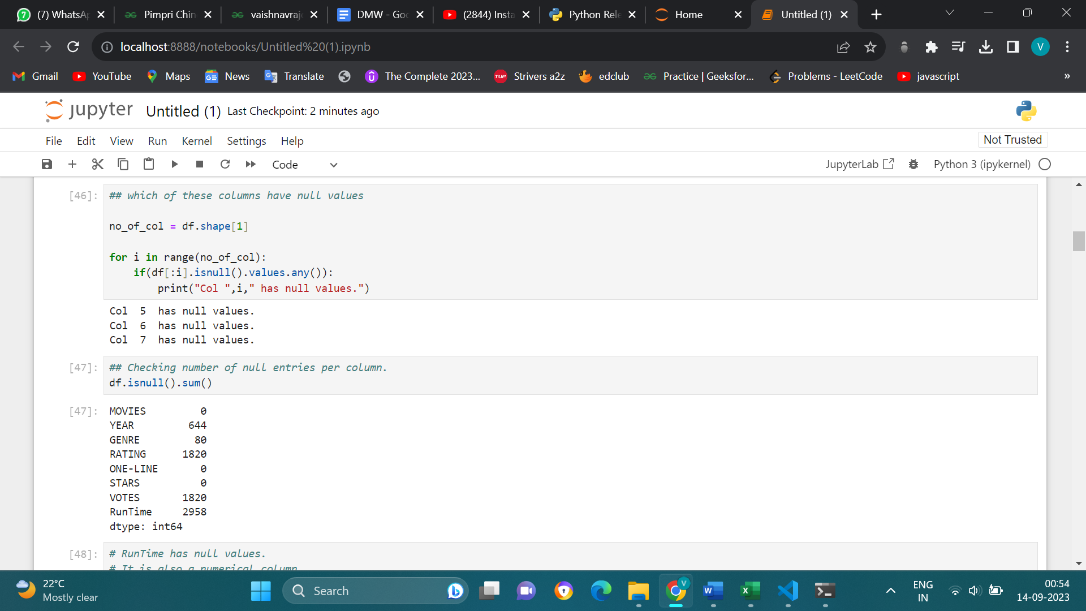

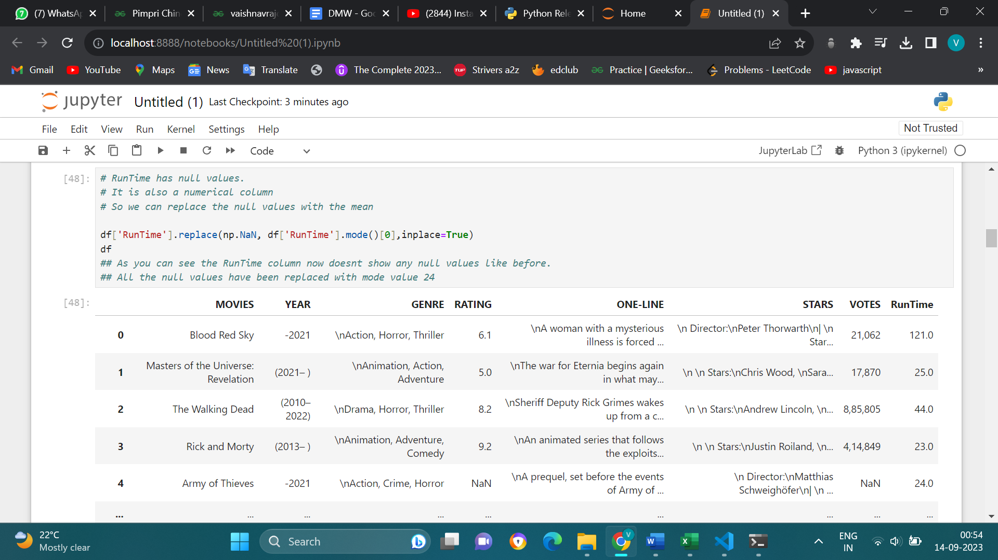

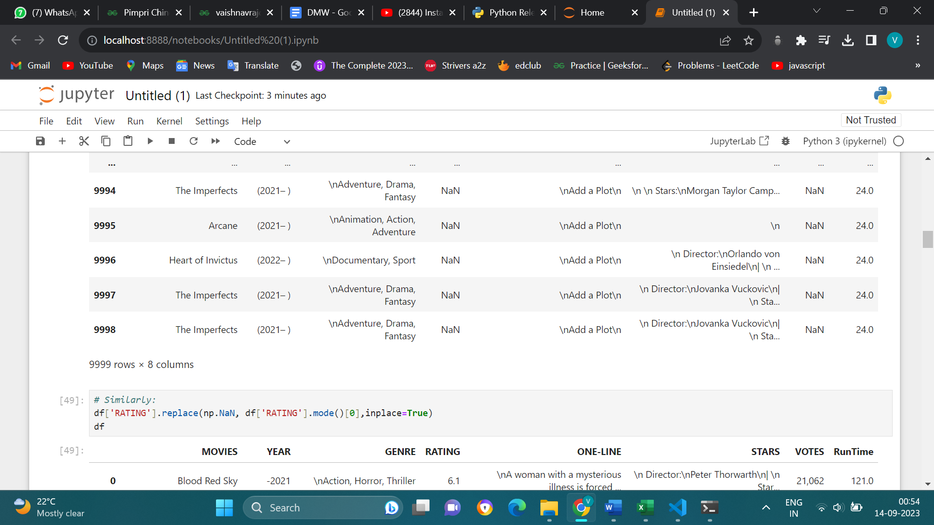

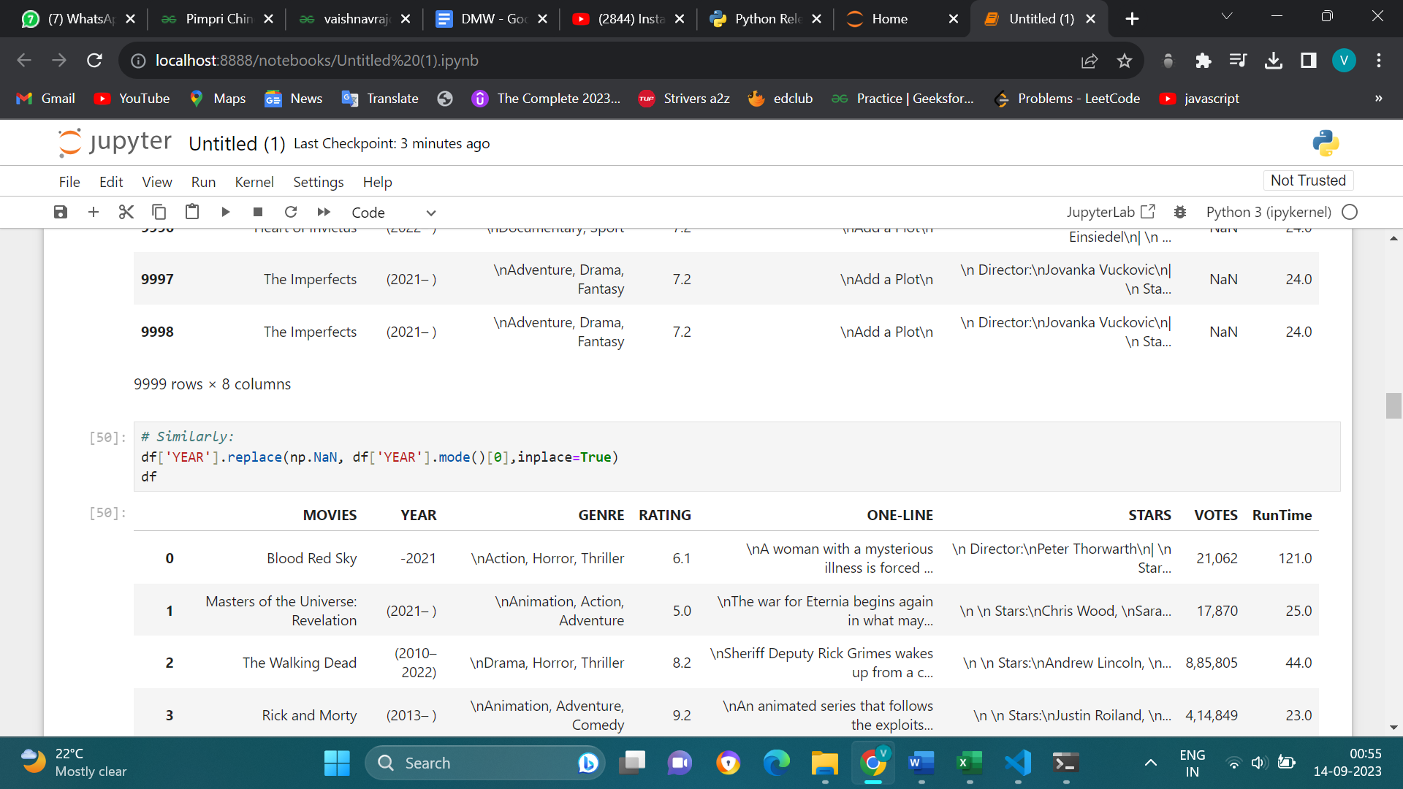

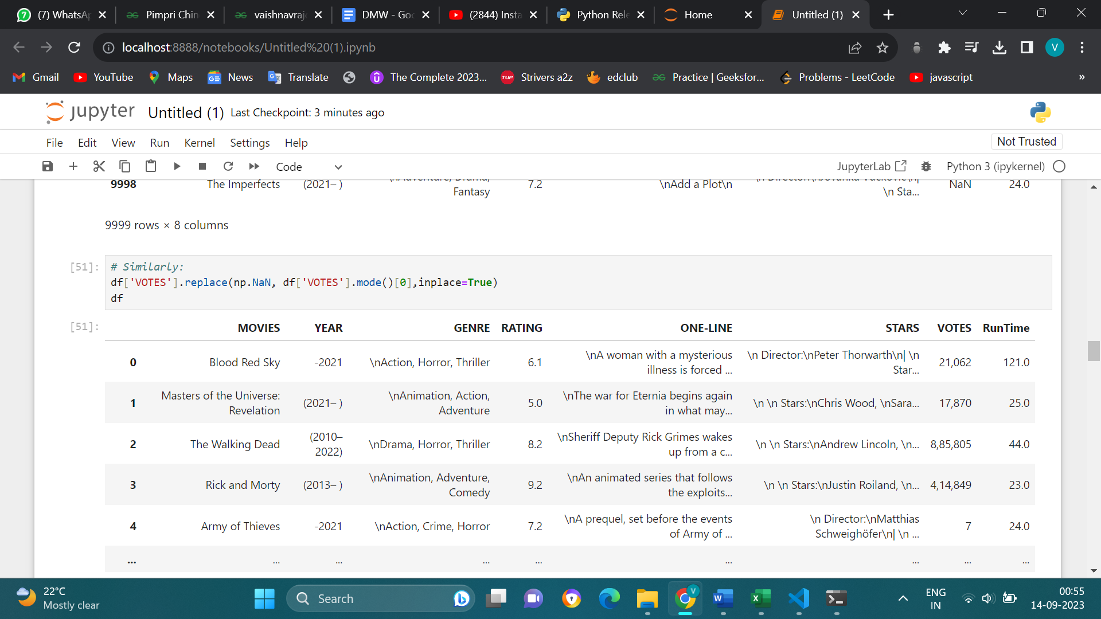

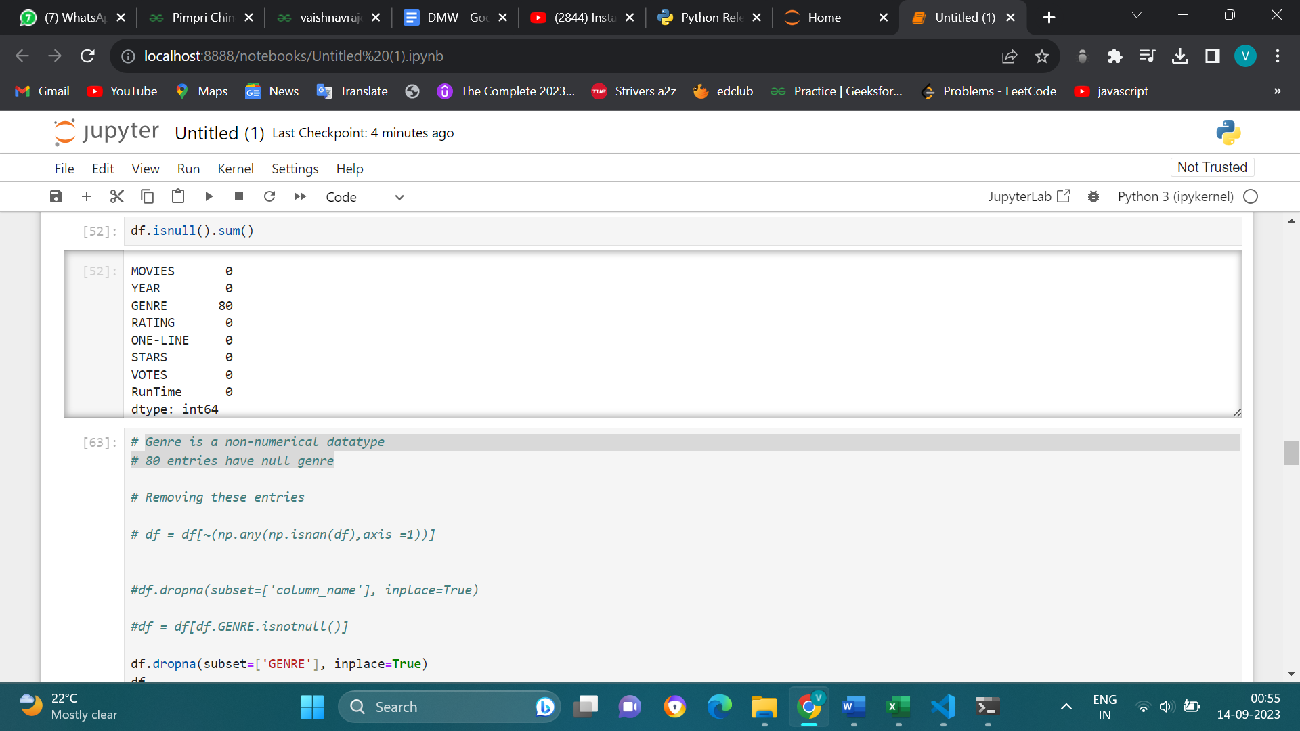

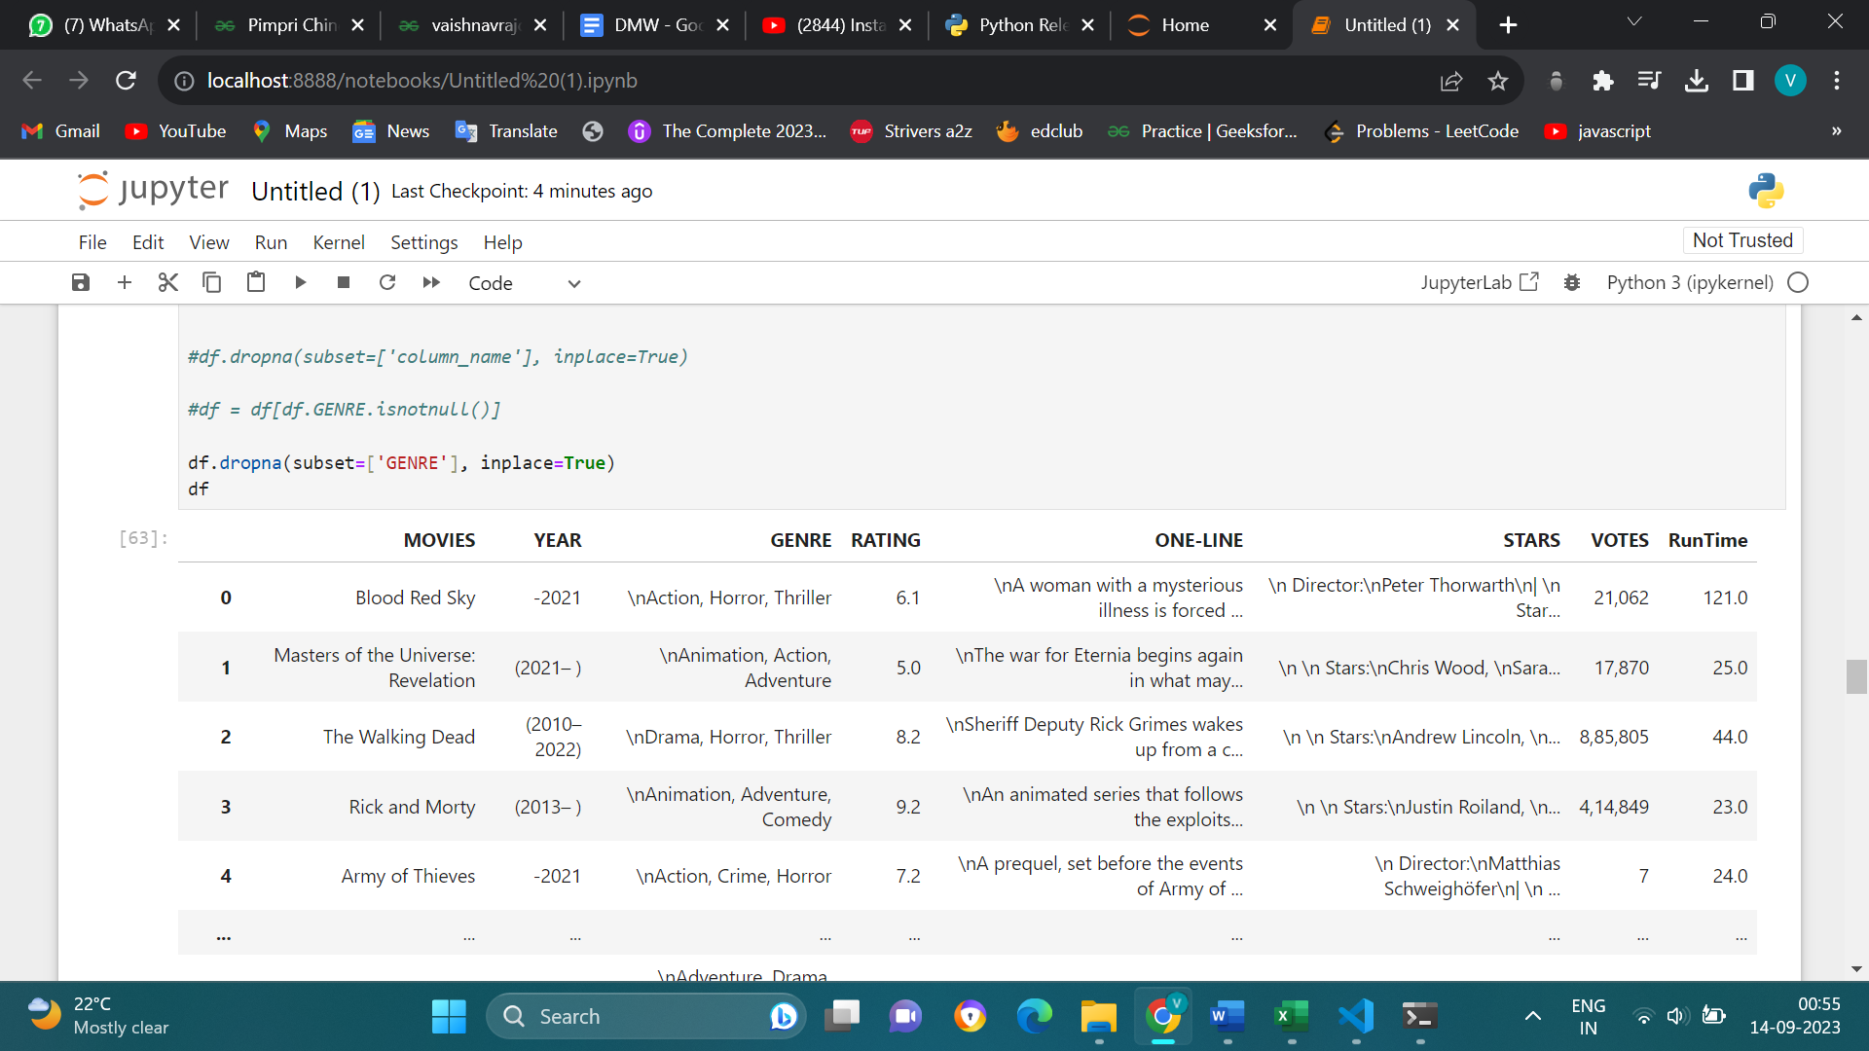

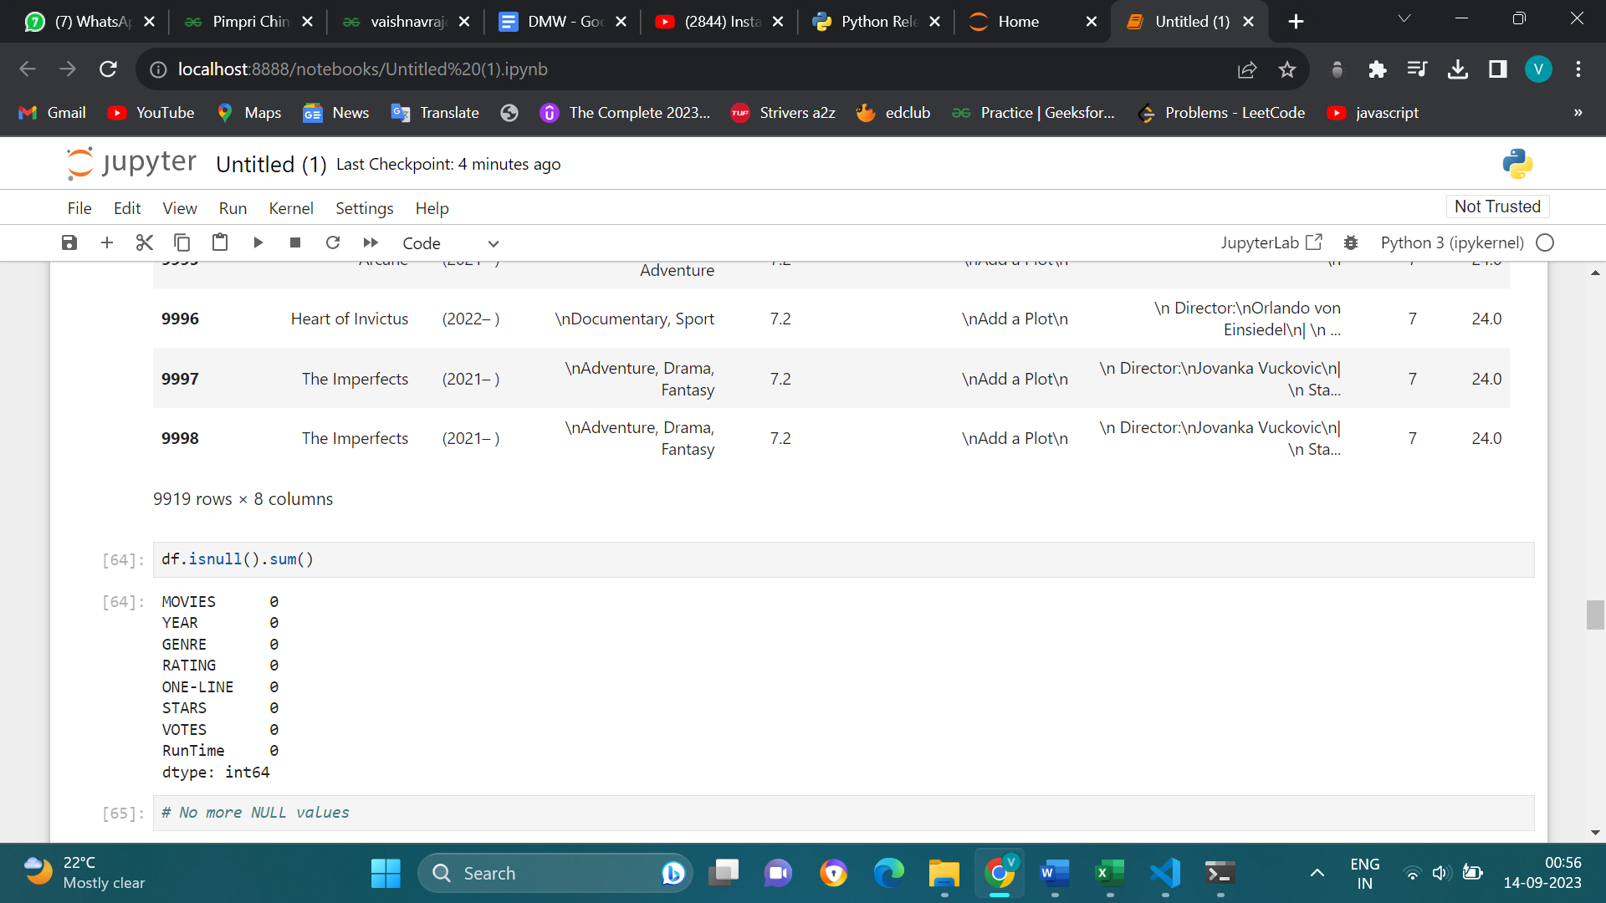

**Dealing with duplicate values**

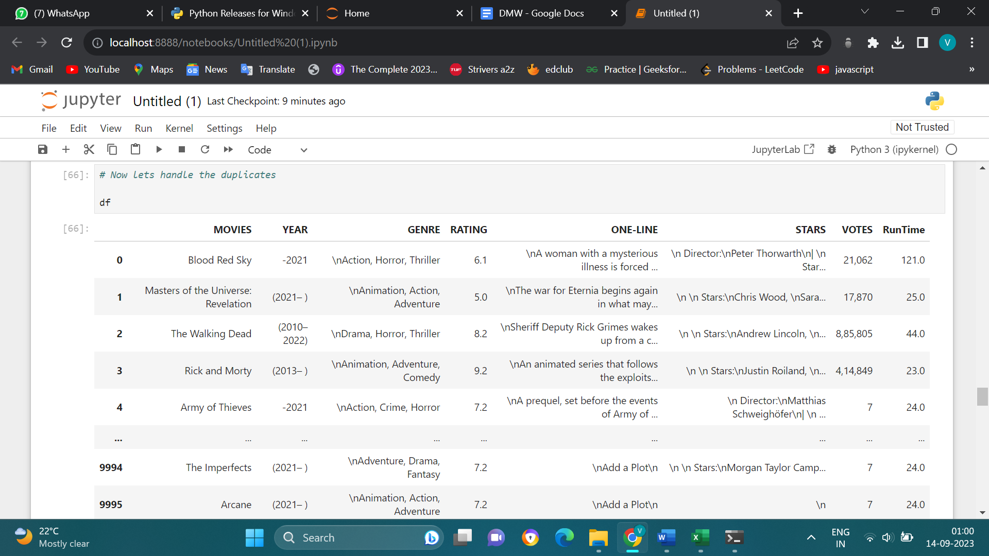

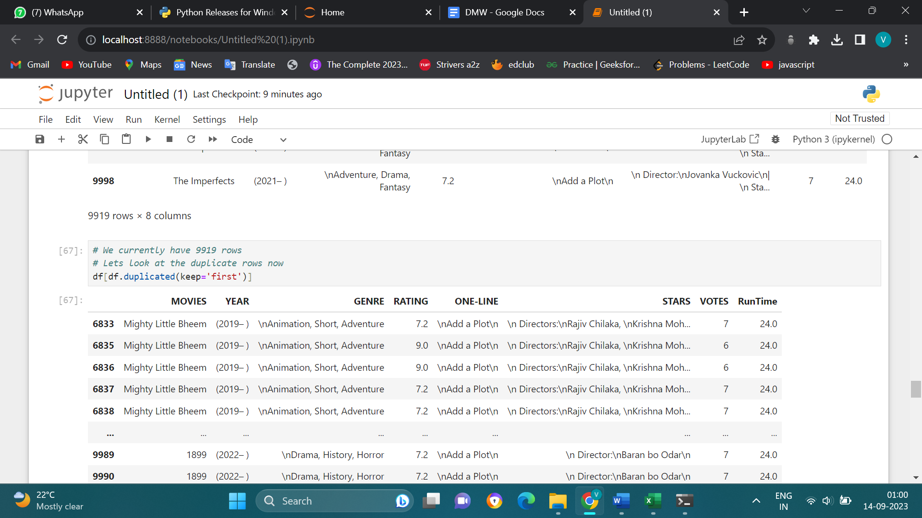

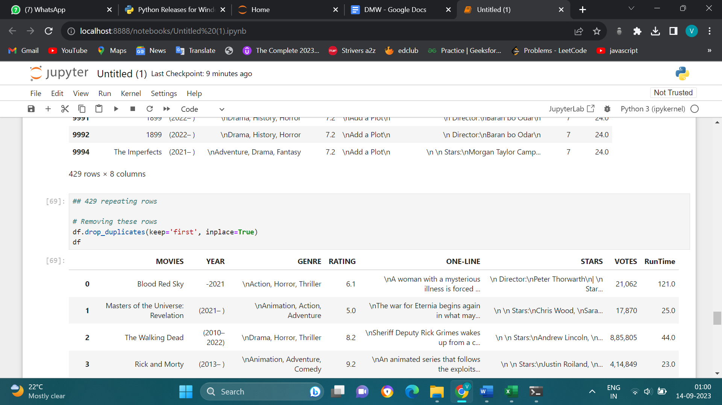

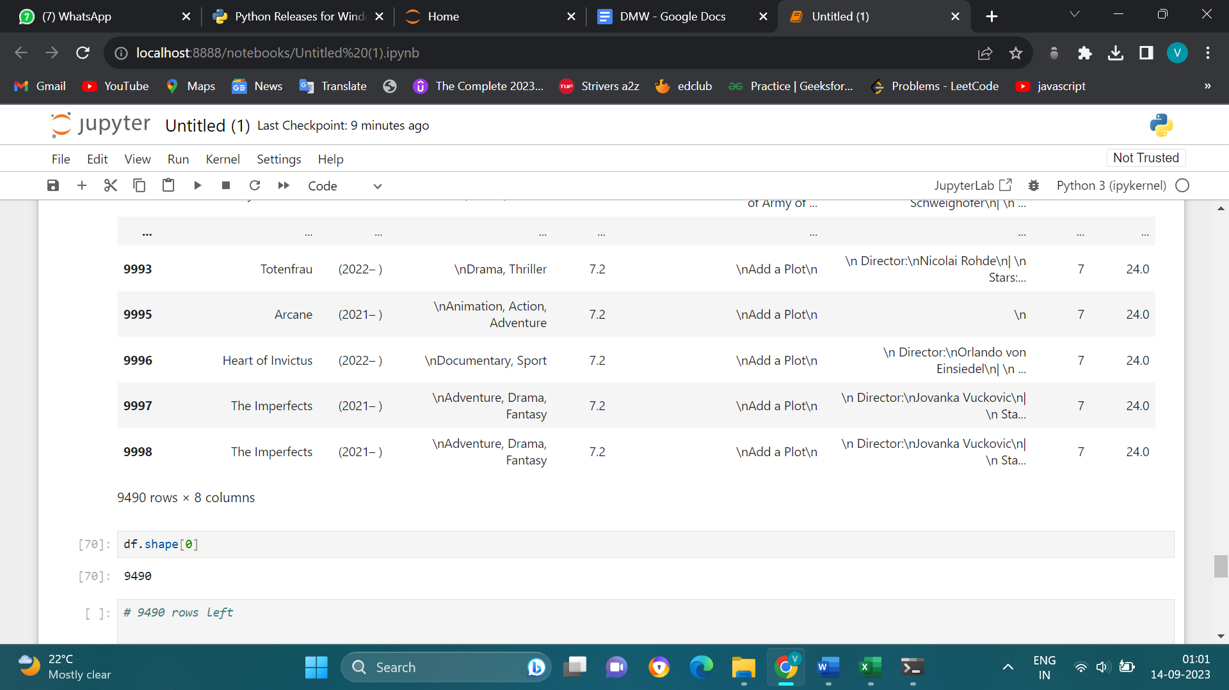

**Handling outliers**

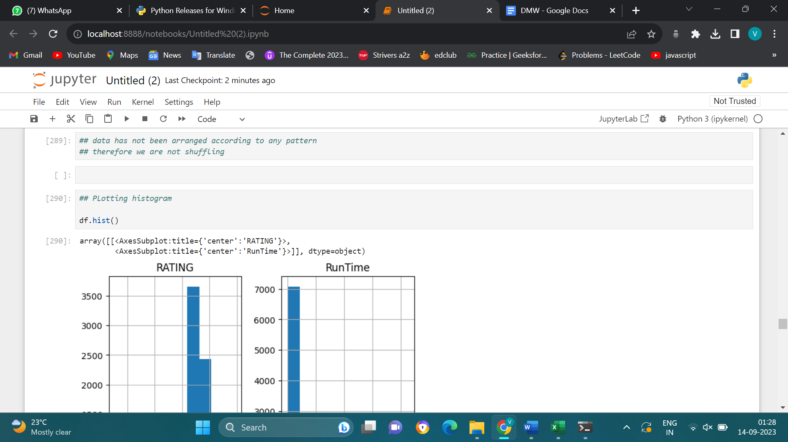

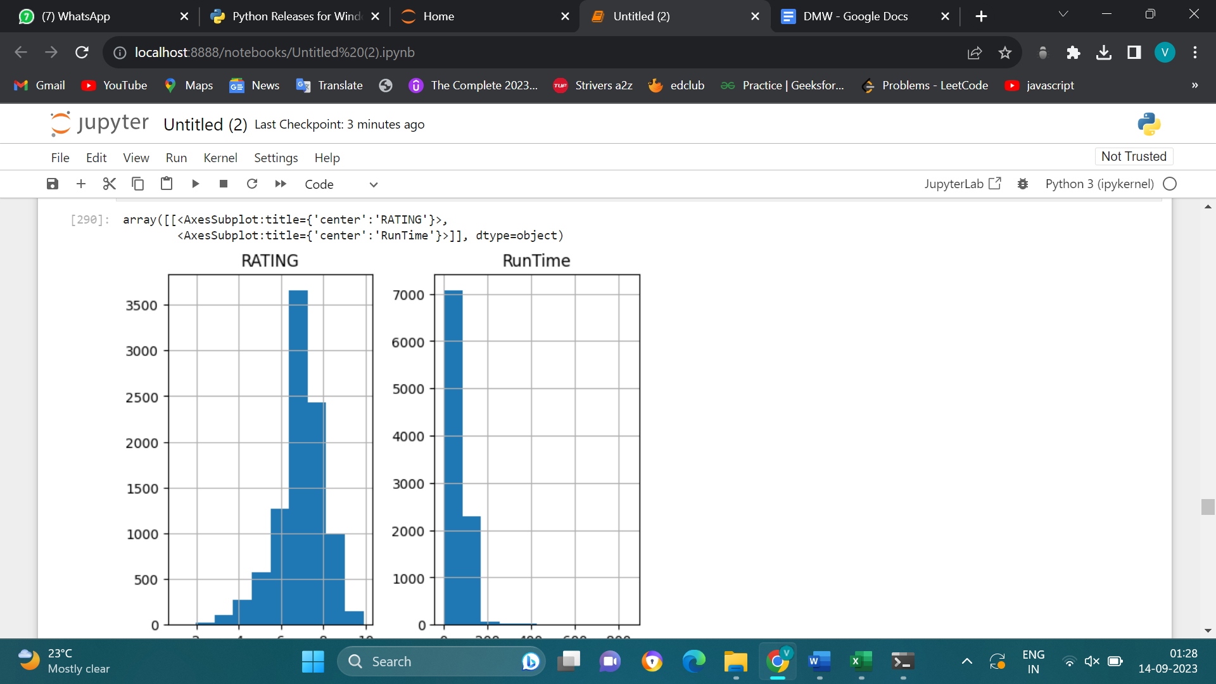

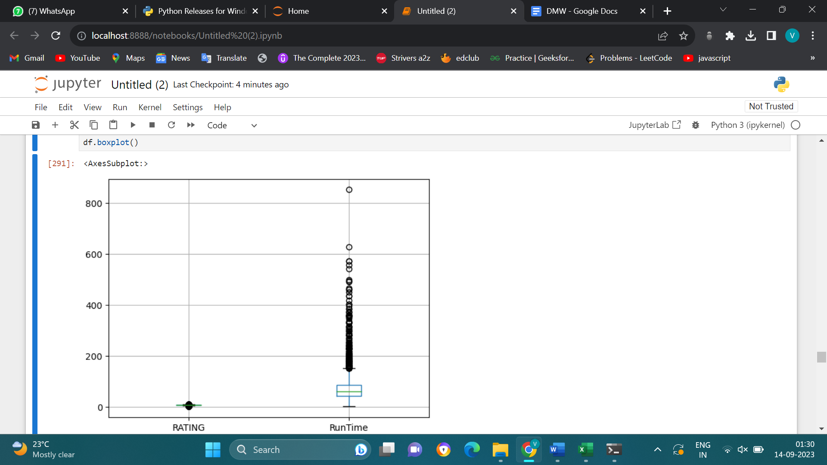

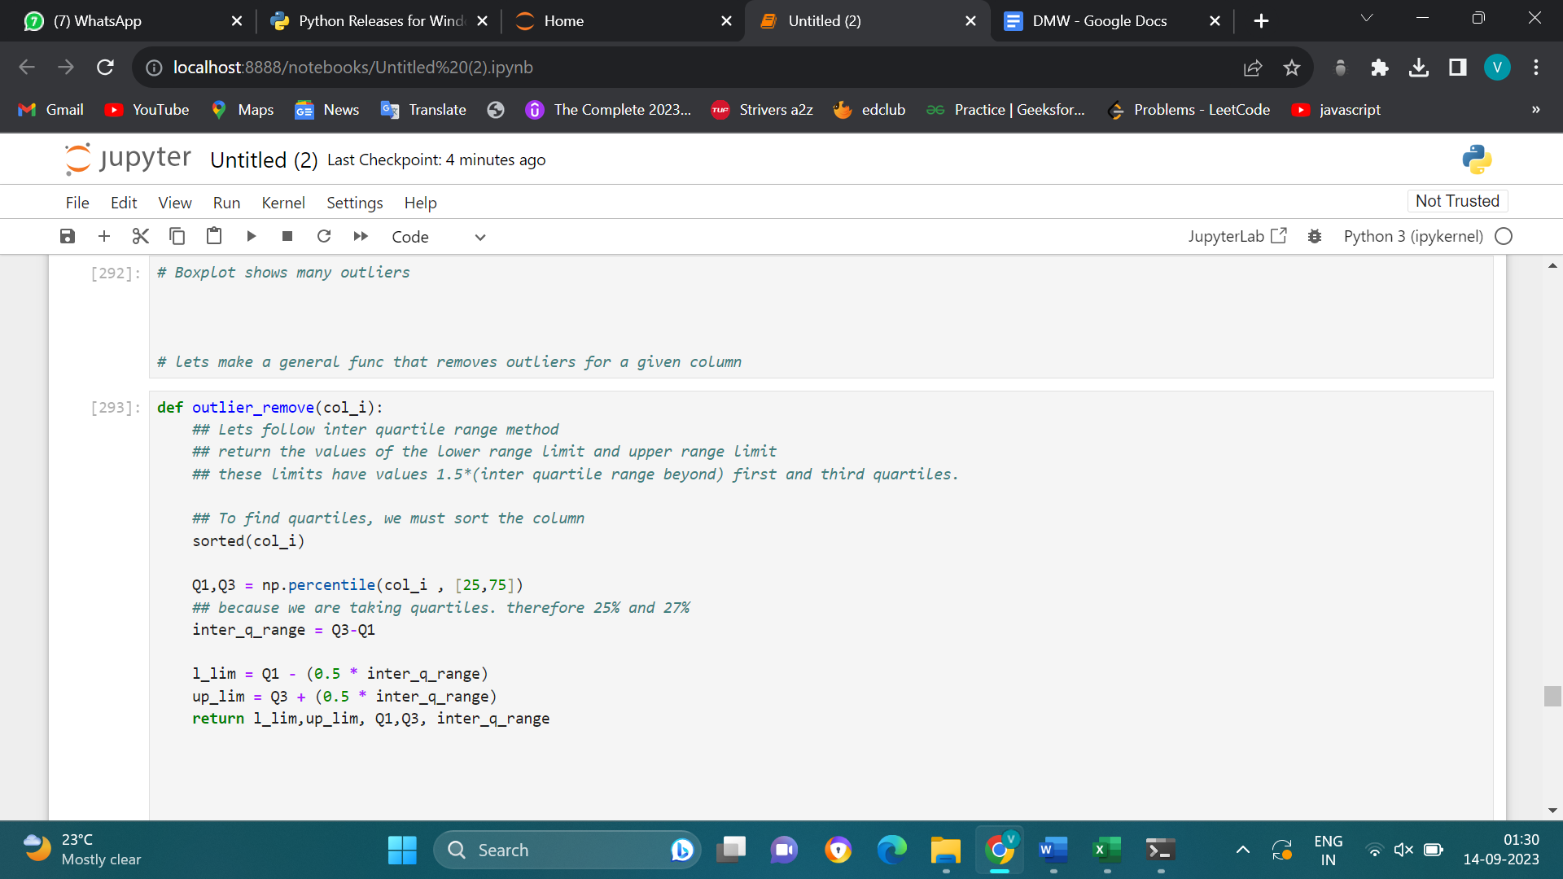

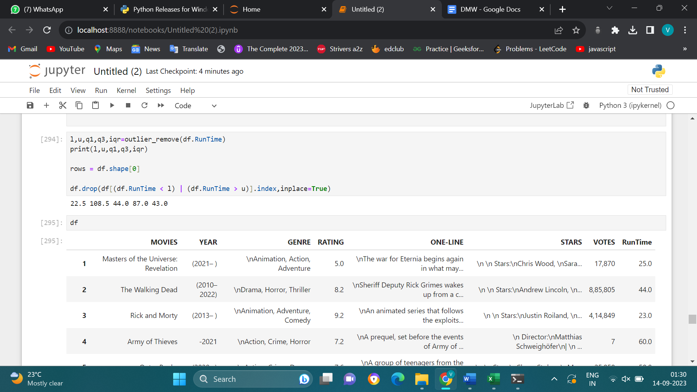

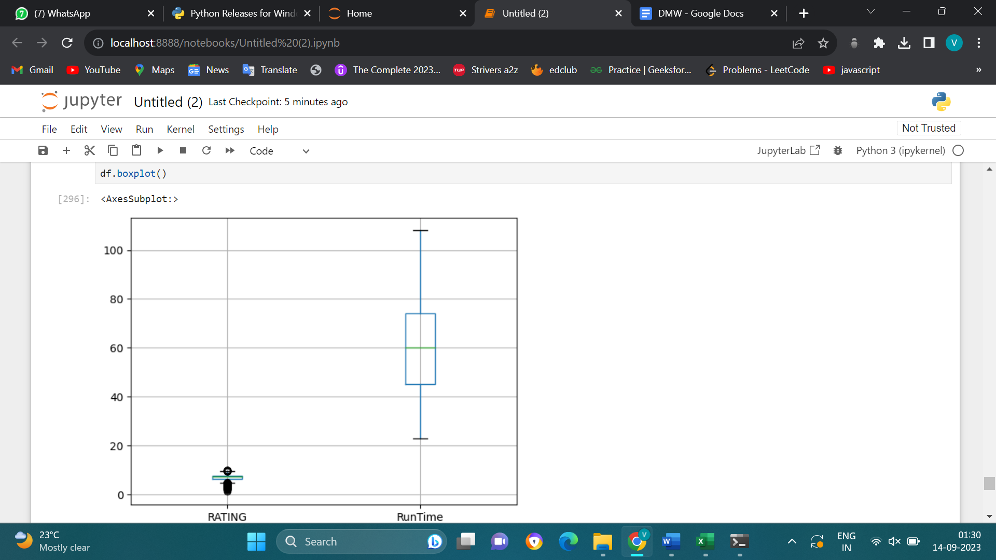

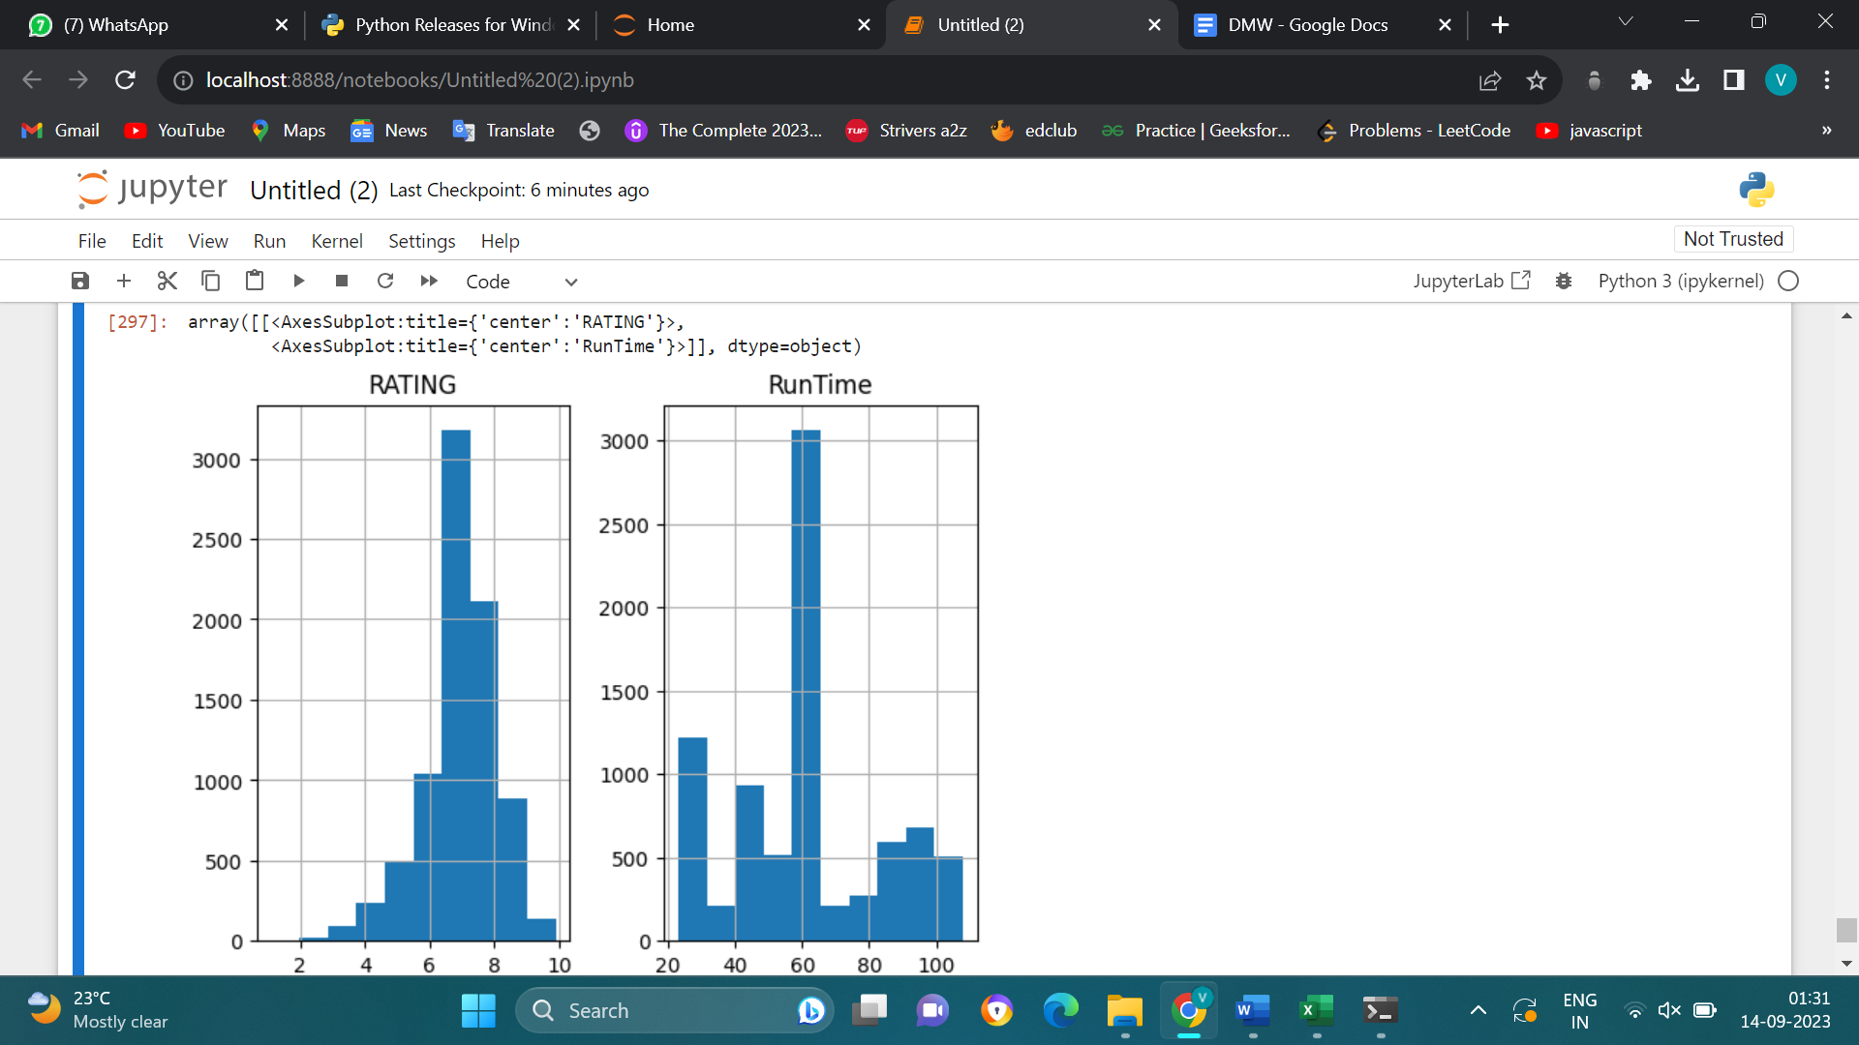

**Conclusion:-**

Our data has all the required columns required for Machine Learning (no unnecessary data). We have eradicated all the NULL values and duplicates from the raw data, and finally we have handeled the outliers.